Website Development Project Proposal 2
Web Development
WEDE5020
Nozithelo Ntini
ST10519223
Group 2

Table of Contents
1. QuickFix Organisation Overview 3
Organisation History 3
Mission Statement 4
Vision Statement 4
Target Audience 4
2. Website Goals and Objectives 4
Key Goals 4
Key Performance Indicators (KPIs) 4
3. Current Website Analysis 5
Strengths of Current Online Presence 5
Weaknesses 5
Areas for Improvement 5
4. Proposed Website Features and Functionality 5
Homepage 6
About Us Page 6
Services Page 6
Repair Request Page 6
Contact Page 7
5. Design and User Experience 7
Colour Scheme 7
Typography 7
Layout and Design 8
User Experience Considerations 8
Low-Fidelity Wireframes 9
6. Technical Requirements 9
7. Timeline and Milestones 10
8. Budget Estimate 10
References 11

- QuickFix Organisation Overview
Name
QuickFix Tech Repair
(OpenAI, 2026)
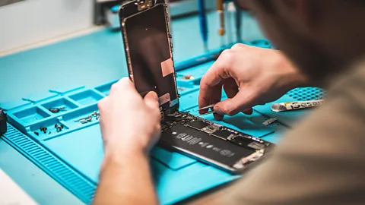
(Stokel-Walker, 2023)

Organisation History
QuickFix Tech Repair is a small technology repair business that focuses on fixing common electronic devices such as mobile, laptop, and tablet. The business caters to individuals and small businesses with fast and inexpensive repair services.
The company was formed because more people are relying on technology for working, communicating and everything else so people do need device repair. Many repair customers opt for a quicker and more cost effective service as opposed to an expensive device.
The business currently operates through referral and walk in customers. Not having a website means customers need to call them up to get quick information about the service, pricing, repair, etc. By creating a website, QuickFix Tech Repair will be able to enhance visibility and make it easier for customers to contact them.

Mission Statement
To provide reliable, affordable and efficient technology repair services that help customers extend the life of their devices.

Vision Statement
To be a trusted local repair service that values quick turnaround times, transparent pricing and quality customer service.

Target Audience
The primary target audience includes:
- Students that are studying on laptops and phones.
- Employed professionals that require quick device repairs.
- Business owners with technology related problems.
- People looking for economical alternatives to device replacement.
(oluwabariu, 2025)
- Website Goals and Objectives

Key Goals
- Increase the online visibility of QuickFix Tech Repair
- Provide detailed information about repair services offered
- Allow customers to submit repair enquiries online
- Improve customer trust through a professional online presence
- Reduce repetitive customer questions by providing clear information and an FAQ page

Key Performance Indicators (KPIs)
The effectiveness of the website can be measured using the following KPIs:
- Number of monthly website visitors
- Number of repair enquiry submissions
- Increase in walk in customers who discovered the business online
- Time spent on service information pages
- Number of returning visitors
- Current Website Analysis
QuickFix Tech Repair currently does not have an official website. Customers mainly discover the business through social media pages and word of mouth.

Strengths of Current Online Presence
- Active social media pages showing completed repairs
- Direct interaction with customers through messaging
- Ability to post updates and promotions

Weaknesses
- There is no central location for detailed service information
- Customers cannot easily check repair options or pricing
- No structured way for customers to request repairs online
- Limited credibility without a professional website

Areas for Improvement
A dedicated website would improve accessibility to information and make it easier for customers to understand the services offered before visiting the store.
- Proposed Website Features and Functionality
The website will include several key pages that provide essential information and allow customers to contact the business easily.

Homepage
The homepage will provide an overview of the business and highlight key services offered.
Features include:
- Introduction to QuickFix Tech Repair
- Detailed run down of common repair services
- Featured customer testimonials
- Call to action encouraging customers to request a repair

About Us Page
This page will include:
- Background information about the business
- Description of the repair team
- Commitment to quality service

Services Page
This page will outline the types of repairs offered, including (but isn’t limited to):
- Smartphone screen repairs
- Laptop troubleshooting and repair
- Battery replacement
- Software troubleshooting and virus removal

Repair Request Page
Customers will be able to submit a repair enquiry through an online form. The form will allow users to provide:
- Device type
- Description of the problem
- Contact details
- Preferred repair date

Contact Page
This page will include:
- Business contact details
- Physical location
- Email contact
- Links to social media platforms
- Design and User Experience

Colour Scheme
The proposed colour palette will include:
- Dark blue or navy as the primary colour
- White or light grey backgrounds
- Bright accent colours such as teal or electric blue
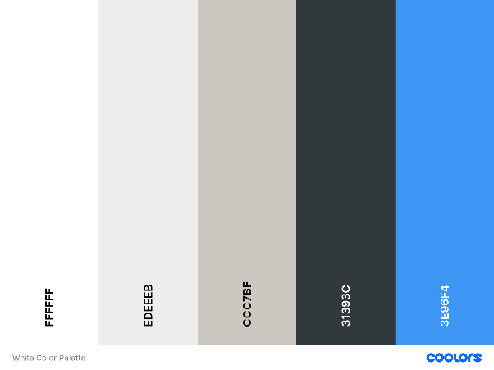
(Ridha, n.d.)

Typography
Proposed fonts include:
Headings: Montserrat
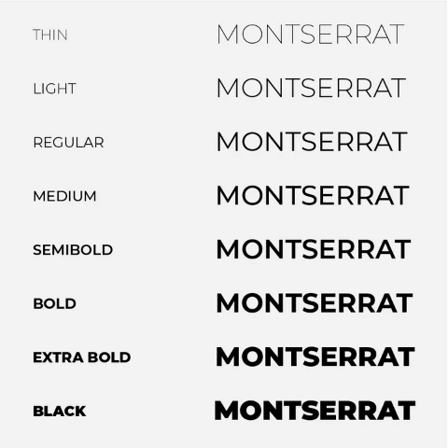
(Visor, n.d.)
Body text: Roboto or Open Sans
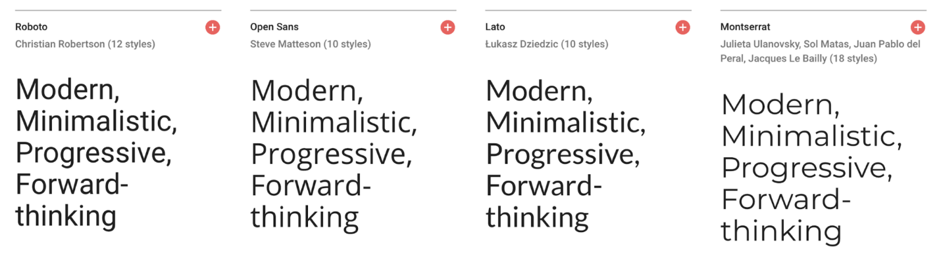
(Hallur, 2024)

Layout and Design
Key layout considerations include:
- Simple top navigation menu
- Clear service categories
- Structured information sections
- Mobile friendly design

User Experience Considerations
Important considerations include:
- Easy navigation between pages
- Clear booking instructions
- Fast loading pages
- Mobile responsiveness
- Simple enquiry form

Low-Fidelity Wireframes
- Website Layout will follow this outline:

- Technical Requirements
The website will be developed using standard web development technologies.
Hosting and Domain
Domain example: quickfix.co.za
Web hosting through providers such as Afrihost or xneelo
Programming Languages and Technologies
The website will be built using:
- HTML
- CSS
- JavaScript
(Wandrag, 2023)
- Timeline and Milestones
Phase | Milestone | Estimated Time
Planning | Proposal submission and approval | Week 1
Research | Content research and information gathering | Week 2
Design | Wireframe development | Week 3
Development | Website coding and page creation | Week 4
Testing | Usability testing and corrections | Week 8
Final Submission | Completed website project | Week 10
(Mika, 2026) ((IIE), 2026)
- Budget Estimate
Item | Estimated Cost
Domain Registration | R120 – R200 per year
Website Hosting | R100 – R200 per month
Website Development | R3,000 – R7,000 once off
Website Maintenance | R500 – R1,000 per month
(OpenAI, 2026)

References
(IIE), T. I. I. o. E. U., 2026. WEB DEVELOPMENT WEDE5020 POE. [Online]
Available at: <https://advtechonline.sharepoint.com/:w:/r/sites/TertiaryStudents/_layouts/15/Doc.aspx?sourcedoc=%7BF3EFB2BA-E0FA-4B85-B2F0-644C7BC04F04%7D&file=WEDE5020POE.docx&action=default&mobileredirect=true>
[Accessed 13 March 2026].
Hallur, A., 2024. 21+7 Fonts for Websites to Boost Readability (Science-Backed). [Online]
Available at: <https://bloggingx.com/fonts-for-websites/>
[Accessed 13 March 2026].
Mika, A., 2026. Website Development Timeline. [Online]
Available at: <https://www.ramotion.com/blog/how-long-to-develop-website/>
[Accessed 11 March 2026].
oluwabariu, 2025. Target Audience for Mobile Repair Services. [Online]
Available at: <https://www.scribd.com/document/870278672/Assignment-1-Mobile-Phone-Repair-Audience>
[Accessed 12 March 2026].
OpenAI, 2026. Chat-GPT (Version 5.3). [Online]
Available at: <https://chatgpt.com/>
[Accessed 11 March 2026].
Ridha, n.d. 10 Aesthetic color palettes for your professional services brand. [Online]
Available at: <https://www.twelveandtwentyeight.com/blog/10-aesthetic-color-palettes>
[Accessed 13 March 2026].
Stokel-Walker, C., 2023. How the right to repair might change technology. [Online]
Available at: <https://www.bbc.com/future/article/20231027-how-the-right-to-repair-might-change-technology>
[Accessed 12 March 2026].
Visor, n.d. Visor Guide for Typography. [Online]
Available at: <https://visorblinds.com/pages/visor-guide-for-typography>
[Accessed 13 March 2026].

